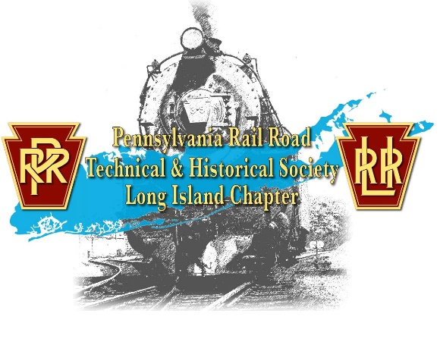
The Pennsylvania Railroad Technical
and Historical Society: Long Island Chapter’s
First Ever Collectable Car Kit
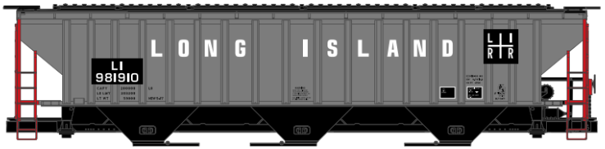
Tichy Scheme Covered Hoppers
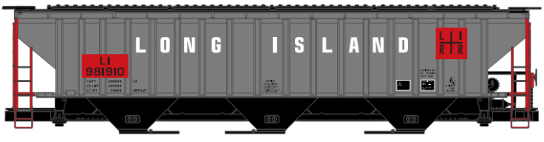
PRRTHS: LIC proudly presents its first ever collector’s car, the Tichy Scheme covered hopper. We have limited stock on this item.
The cost of the cars is $30 each, with shipping. For any questions, please email PRRTHSLIC@gmail.com.
NOTE: These cars are Accurail car kits. Some assembly required.

PRRTHS: LIC
P.O. Box 5827
Bay Shore, NY 11706-5827
------------------------------------------------------------------------------------------------------------------------------------------
I would like to order _______ Black Placard Covered Hopper car(s) at $30.00 each: $____________
I would like to order _______ Red Placard Covered Hopper car(s) at $30.00 each: $____________
Name: ___________________________________________________ Order Total: $____________
Check #: ________ PLEASE PRINT Address: __________________________________________________
City: __________________________________________ State: ____________ Zip Code: _____________
E-mail address: __________________________________ Phone Number: ________________________
Authorizing Signature: __________________________________________________________________
Tear at the dashed line, mail this form with a check or money order for the order total to the address listed above.

